**In-class Exercise**

**1.Create a Centered Box**

**Task**:

1. **HTML Structure**:
   * Create an HTML document with <head> and <body> sections.
   * Within the <body>, use a <div> tag to create a box and assign it a class name intro.
2. **CSS Styling**:
   * Define CSS styles for the intro class within the <style> tag in the <head> section.
   * Set the introduction box's width to 500px, height to 500px, and border to a 3px solid green line.
   * Center the introduction box horizontally on the page and center the text inside both horizontally and vertically.
3. **Content**:
   * Add text content within the introduction box.

**Note**:

* You can use margin: auto; to center the introduction box horizontally.
* You can achieve vertical centering of text by setting the line-height property to the same value as the element's height, combined with text-align: center; for horizontal centering.

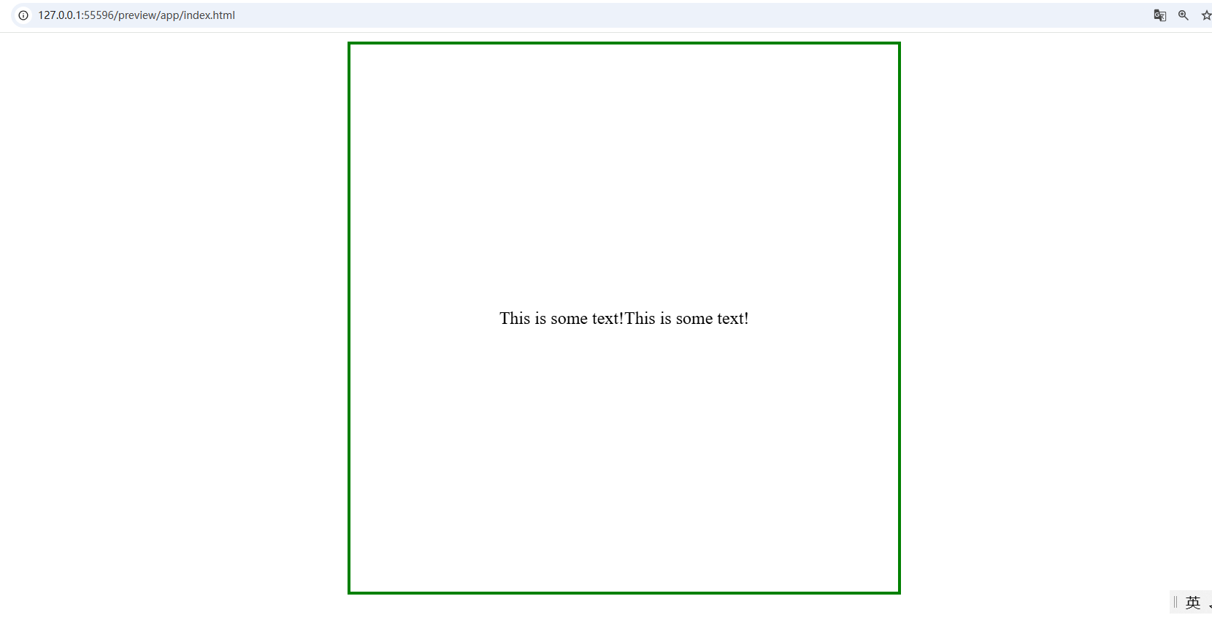

### 2. Floating Div Elements

**Task**:

Create an HTML document featuring three <div> elements, each with distinct background colors and floating side-by-side. Ensure uniform dimensions, centered text, and specified styling.

**Requirements**:

1. **HTML**:
   * Structure your document with <head> and <body>.
   * Include a heading (<h2>) and descriptive paragraph (<p>).
   * Add three <div> elements, each with unique class names.
2. **CSS**:
   * Define styles within <style> in <head>.
   * Apply float: left; to all <div>s.
   * Set width, height, centered text, and background colors.

**Notes**:

* Avoid using inline styles; define all styles in <style>.

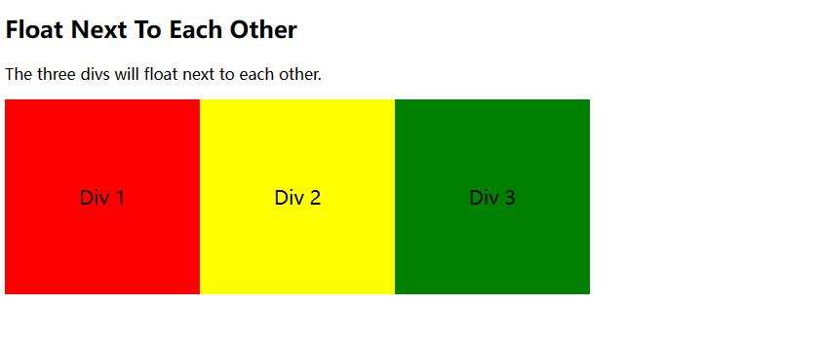

### 3. Modern Clearfix to Clear Floats

**Task**:

Create an HTML document that includes an image floated to the right and a text paragraph wrapped around its left side and below. Use the modern Clearfix technique to ensure that the parent container correctly wraps around these floated elements.

**Requirements**:

1. **HTML Structure**:
   * Create a standard HTML document structure, including <head> and <body> sections.
   * Add a heading <h2> within the <body> to describe the functionality you are implementing.
   * Include a <p> element to explain the purpose of Clearfix.
   * Create a <div> element with the class name clearfix to contain the image and text.
2. **CSS Styling**:
   * Define CSS styles within the <style> tag.
   * Set border and padding for the <div> element.
   * Use a class selector to float the image to the right.
   * Define the .clearfix::after pseudo-element, using the modern Clearfix technique (content: ""; clear: both; display: table;) to clear the floats.

**Notes**:

* Ensure that the image path is correct. If the image does not exist, replace it with a valid image path.
* Properly set the properties of the .clearfix::after pseudo-element to achieve the Clearfix functionality.

